Endangered Wise Men Studios –Policies, Master Content Disclaimer
Studio Policies
Here at EWM Studios, we are fortunate enough to stay consistently booked. That being said, due to the high volume of clients requesting backups of sessions or .wav files to be sent and resent via email, we have to charge for that time (usually about 1 hour*). Please know that the best way to backup your files is by bringing a hard drive (formatted for Mac and preferably USB) with you and backing up at the end of your session.
*some files/sessions that are much older or larger in size may require more than one hour.
Please also note that there is a 48 hour cancellation policy. It is the responsibility of the client to notify the studio of a cancellation or change in scheduling. If your session needs to be cancelled or rescheduled for a different time, please give us at least 48 hours of notice. We will try our best to reschedule your session, but please be aware that sessions cancelled or rescheduled with less than 48 hours of notice may forfeit full or partial deposit, and your time may be forfeited to another client.
Master Content Disclaimer
Please remember to bring a hard drive with you in order to back your master recording sessions up to at the end of your scheduled recording session. This agreement will explain Endangered Wise Men Studio’s policy regarding the client’s responsibility to back up their master recordings at the end of each recording session and to keep a personal record for their archives.
If you bring your own hard drive with you to your session, we will gladly back up your master recording files at the end of the session at no additional fee. Please note that we will only back up your master recording sessions if you the client request that we do so at the end of each recording session. If you do not request to take your master recordings with you, it is possible that they “could” become “lost for good” due to Endangered Wise Men Studio’s daily hectic recording schedules and the nature of digital recording. Computers and hard drives break down and “Master Recording Session Files” become unexplainably corrupted files that will no longer work. Protect your master recordings at all times and be positive that you have a copy of your master files backed up and in your possession at all times.
At Your Session’s End Here Is How To Backup Your Master Recordings:
Supply us With an USB 3.0 Hard Drive: Bring your own external or USB 3.0 Hard Drive and we will back up your master recording sessions at no additional fee at the end of your session. Simply request that the engineer perform the service and it will be done. If you do not request this service, the service will not be performed and you run the risk of losing your recordings.*
*If you choose not to transfer your master recording sessions using the above method, Endangered Wise Men Studios will not responsible or liable in any way if your master recording sessions are lost from our archives for ANY REASON! This clause has no limitations whatsoever.
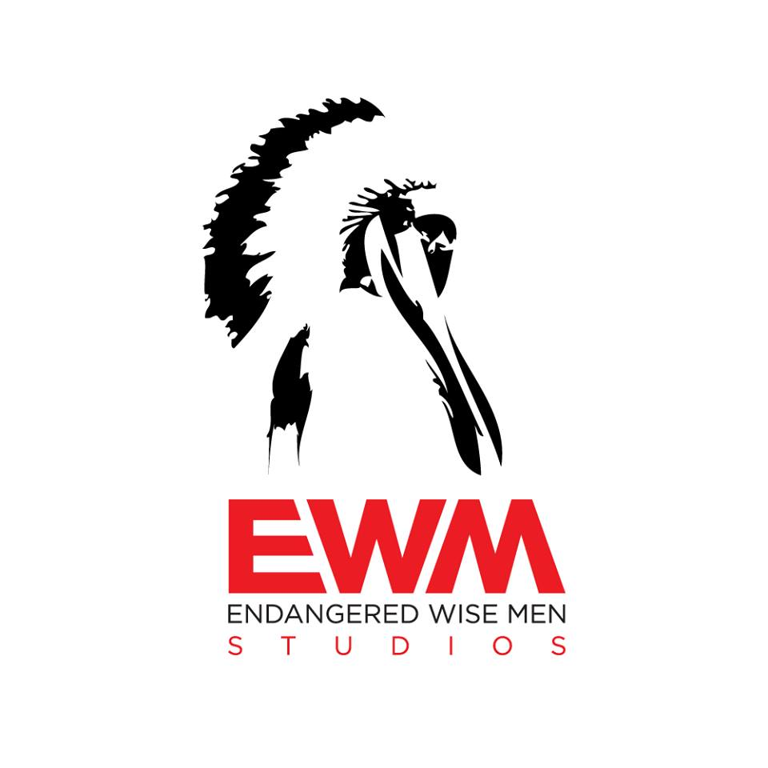
This is a lifetime agreement stating that you understand the policies regarding backing up your master content. By signing this agreement, you are agreeing that you have discussed this with all of the members involved in your act. Furthermore, you are stating that all of the other members give you power of attorney to sign on behalf of the entire act and that you are representing the entire act or artist(s).
Artist Print x_______________________________________
Artist Sign x________________________________________
Date_____/_____/_______

